[Array 17 (2023) 100272](https://doi.org/10.1016/j.array.2022.100272)

|  |  |  |
| --- | --- | --- |
|  | Contents lists available at [ScienceDirect](https://www.elsevier.com/locate/array) |  |
| Array |
| journal homepage: [www.elsevier.com/locate/array](http://www.elsevier.com/locate/array) |
|  | | |

Harmonizing motion and contrast vision for robust looming detection Qinbing Fu∗,1, Zhiqiang Li1, Jigen Peng∗  
*Machine Life and Intelligence Research Centre, School of Mathematics and Information Science, Guangzhou University, Guangzhou, 510006, China*

|  |  |  |
| --- | --- | --- |
| A R T I C L E | I N F O | A B S T R A C T |
| *Keywords:*  Neural modelling  Neuromorphic computing  Low-contrast looming detection Parallel ON/OFF channels  Contrast neural computation | | This paper presents a novel neural model of insect’s visual perception paradigm to address a challenging problem on detection of looming motion, particularly in extremely low-contrast, and highly variable natural scenes. Current looming detection models are greatly affected by visual contrast between moving target and cluttered background lacking robust and low-cost solutions. Considering the anatomical and physiological homology between preliminary visual systems of different insect species, this gap can be significantly reduced by coordinating motion and contrast neural processing mechanisms. The proposed model draws lessons from research progress in insect neuroscience, articulates a neural network hierarchy based upon ON/OFF channels encoding motion and contrast signals in four parallel pathways. Specifically, the two ON/OFF motion pathways react to successively expanding ON–ON and OFF–OFF edges through spatial–temporal interactions between polarity excitations and inhibitions. To formulate contrast neural computation, the instantaneous feedback normalization of preliminary motion received at starting cells of ON/OFF channels works effectively to suppress time-varying signals delivered into the ON/OFF motion pathways. Besides, another two ON/OFF contrast pathways are dedicated to neutralize high-contrast polarity optic flows when converging with motion signals. To corroborate the proposed method, we carried out systematic experiments with thousands of looming-square motions at varied grey scales, embedded in different natural moving backgrounds. The model response achieves remarkably lower variance and peaks more smoothly to looming motions in different natural scenarios, a significant enhancement upon previous works. Such robustness can be maintained against extremely low-contrast looming motion against cluttered backgrounds. The results demonstrate a parsimonious solution to stabilize looming detection against high input variability, analogous to insect’s capability. |

**1. Introduction**

Insects possess parsimonious visual systems capable of dealing with complex navigation tasks in a both robust and low-energy man-ner [1]. Among visually guided abilities in navigation, looming de-tection, i.e., the perception of objects that approach, is essential to determine a variety of behaviours including predation and defence against natural enemy [2], landing [3], clustering [4], and so forth. In the human world, looming detection is also a frontier of scientific research to build collision-free artificial vision systems in service of mobile robots [5–8], UAVs [9,10], and ground vehicles [11–14]. Typical looming detection methods mainly depend on different sensor strategies, such as radar [15], infrared [16], ultrasonic [17], and visual modalities [18]. In respect of retrieving more abundant of motion features shortly, vision-based methodologies are prevailing over other physical sensing techniques, however suffering from impact by chaotic and dynamic environments. In another word, current artificial vision systems for looming detection are vulnerable to (1) low-contrast

motion, (2) noisy background motion, (3) high solution cost on dealing with high-dimensional features. Although the new technology based on deep learning has good performance in reality, it demands large-scale data sets and consumes large volume of computing resources. In order to leverage system robustness and energy consumption in motion detection, people’s attention is gradually attracted by natural ability. Learning from the homology between looming detection neural systems of different insect species could provide effective, low cost, tractable solutions [19,20].

Locusts and flies are two prominent modelling paradigms to study looming detection strategies. A considerable amount of computational works thus has been proposed to simulate biological visual percep-tion mechanisms for looming detection either at local, optical flows level [19], or in neural networks hierarchy [20]. The advantage of such biologically plausible solutions stems from their resource effi-ciency (or parsimony) especially in terms of power and mass, thus creating many successful applications in micro-machines with restricted

∗ Corresponding au[thors.](mailto:qifu@gzhu.edu.cn)

*E-mail addresses:* [qifu@gzhu.edu.cn](mailto:qifu@gzhu.edu.cn) (Q. Fu), [jgpeng@gzhu.edu.cn](mailto:jgpeng@gzhu.edu.cn) (J. Peng).   
1 Qinbing Fu and Z[hiqiang Li are joi](mailto:qifu@gzhu.edu.cn)nt first au[thors.](mailto:jgpeng@gzhu.edu.cn)

<https://doi.org/10.1016/j.array.2022.100272>  
[Received 14 October 2022; Received in revis](https://doi.org/10.1016/j.array.2022.100272)ed form 10 December 2022; Accepted 13 December 2022   
Available online 16 December 2022   
2590-0056/© 2022 The Author(s). Published by Elsevier Inc. This is an open access article under the CC BY license (<http://creativecommons.org/licenses/by/4.0/>).

*Q. Fu et al.*  *Array 17 (2023) 100272*

computational capacity like micro-mobile robots [21–23], micro aerial vehicles [24–26], and small bio-mimic sensors [27]. Moreover, a few methods have been proposed to enhance the robustness and adaptabil-ity of insect-inspired looming detection models in complex, dynamic environments in recent years [20]. Accordingly, such insect-inspired approaches have, to some extent, overcome the aforementioned prob-lems via filtering out irrelevant background motions and minimizing resource cost with successful applications onto micro-robot [22]. However, current methodologies are still significantly influenced by spatial contrast, the difference of illumination between adjacent local areas of receptive field. The model response temporally fluctuates with high variance against input variability of natural signals. In addition, recognition of low-contrast looming motion has always been a chal-lenging problem for artificial vision systems. The causality would be (1) internally non-linear attribute of motion detection, and (2) externally large variation in local contrast of natural signals [28].

To solve this problem, the research into insect neuroscience recently has revealed their compact neural circuits harmonize motion and con-trast visual processing for robust motion vision against natural signals, though with organizational and functional disparities between different species [29,30]. The neural circuits of fruit fly *Drosophila* have been studied and investigated most intensively [31–34]. Actually, contrast neural computation has been found to play crucial roles which is prob-ably generic to preliminary visual systems of other animals including mammals, concerning their commonalities after millions of years of natural evolution [35]. Biologically dynamic vision systems decently resolve the local contrast issues whereas artificial vision systems are still greatly challenged.

To this end, this paper addresses the local contrast problem in looming detection whereby the proposed method coordinates motion and contrast neural computation in harmony. Specifically, the received signals are split into four parallel ON/OFF channels specializing in en-coding motion and contrast information of visual streams, respectively. The two ON/OFF motion pathways correlate brightness change in order to extract the successive expansion of ON–ON/OFF–OFF edges through spatial–temporal competition between excitatory and suppressive lo-cal response. The contrast neural computation includes instantaneous feedback suppression of preliminary motion arrived at the entrance of ON/OFF motion channels for dynamic normalization of time-varying signals, cascaded with motion correlation. The two ON/OFF parallel contrast pathways are dedicated to attenuate high-contrast optic flows for inhibiting ON/OFF local motion, respectively. In this manner, our proposed model demonstrates significant enhancement in looming de-tection against high input variability of natural signals, especially in extremely low-contrast scenes. To corroborate this model, we created a new data set consisting of thousands of looming-square motions at varied grey scales embedded in different shifting natural backgrounds, as input stimuli. The systematic experiments demonstrated threefold achievements of this research upon previous works:

1. The proposed model coordinates motion and contrast vision within four parallel ON/OFF channels, which works effectively to recog-nize looming motion in extremely low-contrast scenes. The robust-ness against natural signals has been enhanced whereby the model response peaks more smoothly.

2. Compared to the typical model that only handles with motion signals for looming detection [36], the proposed contrast computation can significantly reduce response variance tested by the large visual data set of high input variability.

3. The neuromorphic computing of insect’s four-layer, preliminary vi-sual neural circuits demonstrates a parsimonious and effective solu-tion to stabilize looming detection against natural signals, analogous to insect’s capability.

The rest of this paper is structured as follows: Section 2 reviews re-lated works. Section 3 formulates the proposed neural model. Section 4 evaluates the proposed method. Section 5 concludes this paper.

2

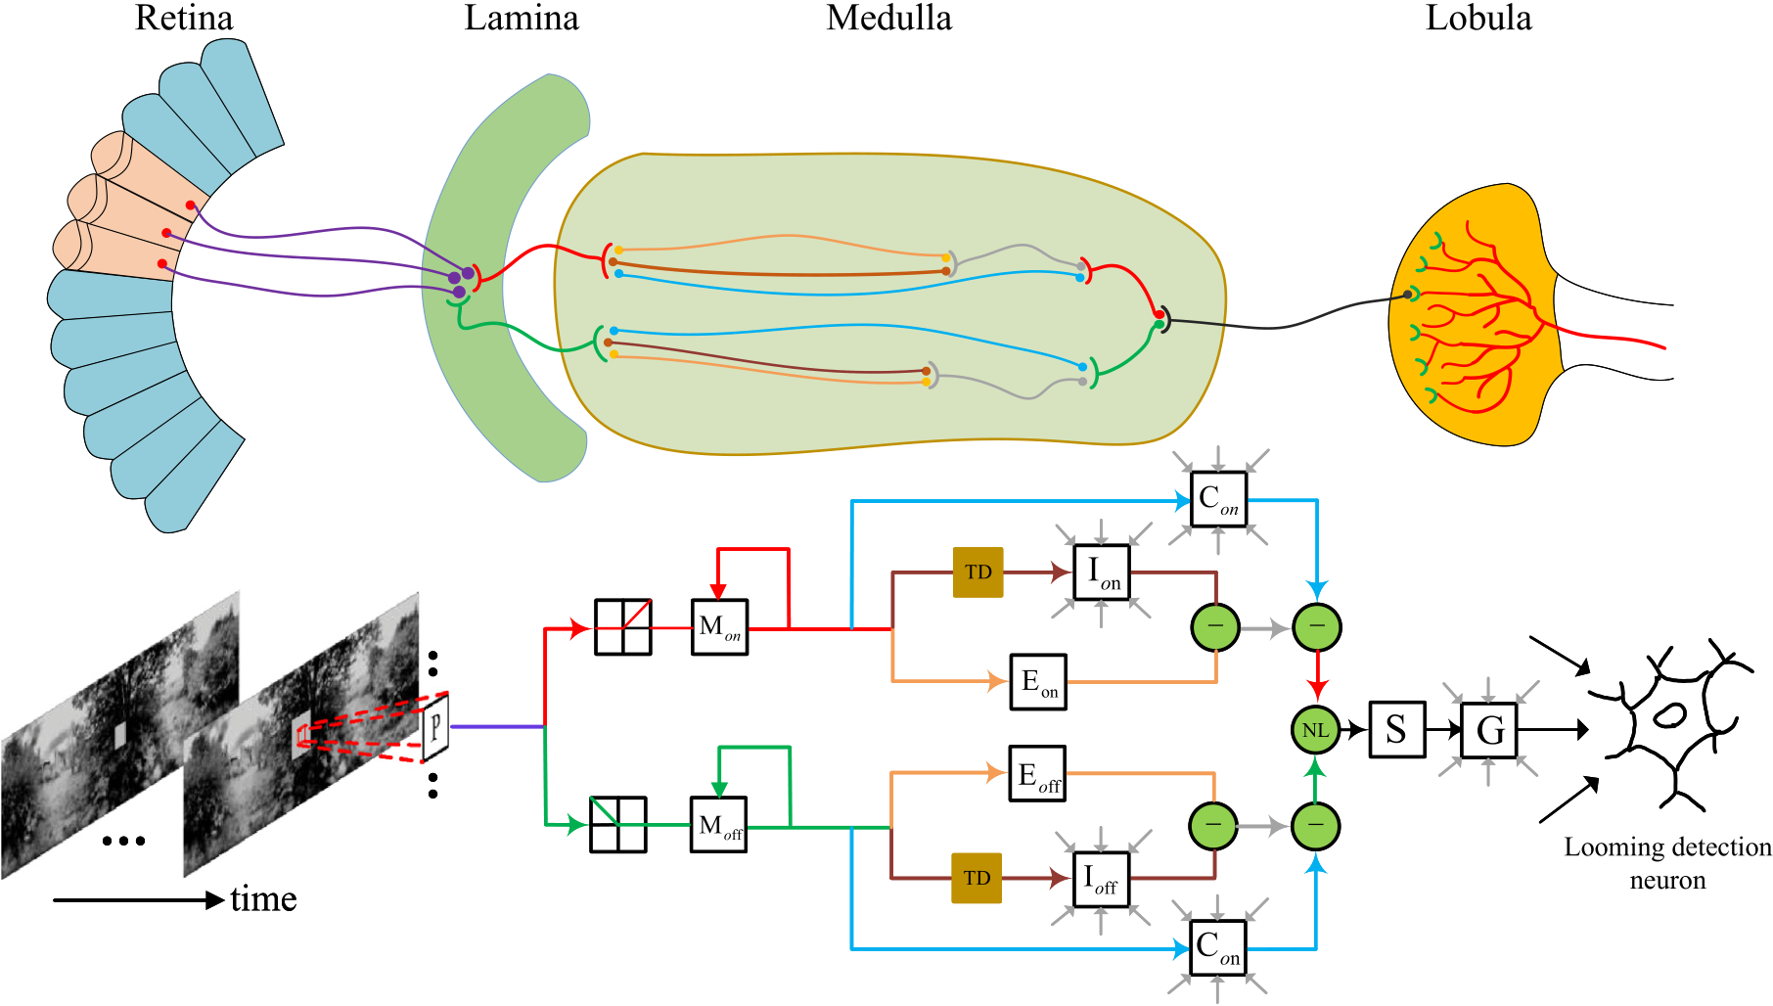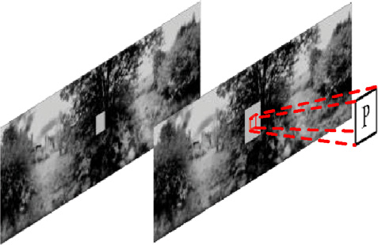

*Q. Fu et al.*  *Array 17 (2023) 100272*

**Fig. 1.** Schematic illustrations of multi-layered preliminary visual systems of insects for looming detection, and the proposed neural model mimicking insect physiology: abbreviations are P: photoreceptor, M: normalized motion unit, E: excitation unit, I: inhibition unit, TD: time delay unit, C: contrast unit, NL: non-linear unit, S: summation unit, G: grouping unit. The visual neural systems consist of four layers of Retina, Lamina, Medulla, Lobula, simulated by the proposed neural model. The red/green pipelines indicate ON/OFF motion pathways respectively, and the blue ones denote contrast pathways. Within ON/OFF channels, inhibition is obtained by convolving surrounding delayed excitations, local contrast is obtained by convolving surrounding unit responses. In the Lobula layer, grouping cell convolves surrounding summation unit responses. The looming perception unit at Lobula integrates all local grouped responses. The flowchart of only one processing unit is shown. Formulation of the proposed neural model is elucidated in Section 3. (For interpretation of the references to colour in this figure legend, the reader is referred to the web version of this article.)

*2.2. Contrast neural computation*

Biological visual systems can perform key survival tasks in complex, dynamic environments, whereas artificial vision systems are far from such capability. Visual contrast issue is critical to be addressed [50,51]. Some mechanisms can adapt to natural signals such as the processing of environmental statistics [52,53]. However, the issue of spatial contrast has not been well resolved which always results in response fluctuation against highly variable input. Accordingly, new methods are requested to address such a problem.

Contrast computation is a general mechanism for neurons to process signals [54,55], not only in visual [29], but also in olfactory [56], and auditory [57] nervous systems. Such circuit mechanism works effec-tively to remove higher-order correlations from natural signals [30, 58]. In fact, there are a few prominent works in fly visual systems to demonstrate the efficacy of neural circuits implementing contrast mechanisms. The authors reported evidence for a non-linear, divisive normalization mechanism to deal instantly with local spatial contrast that emerges at an intermediate neuropil layer of preliminary visual systems, i.e., the Medulla [30]. More precisely, the foreground signal intensity of each Medulla inter-neuron is divided into a neighbouring background field by spatially integrating surrounding feedback signals, the whole process of which happens prior to motion correlation. This bio-plausible mechanism represents dynamic, non-linear properties in normalization as a basis of sensory circuit mechanism. To consolidate it, the authors also compared with feed-forward contrast normalization, and linear, static normalization methods through training a batch of elementary motion detectors (EMD). The instantaneous, feedback, dy-namic contrast normalization can finally fit best with the physiological data. Another research from Bahl et al. pointed out parallel contrast pathways beginning from the Medulla affect motion signals negatively at the Lobula area [29]. Such contrast pathway behaves to attenuate high-contrast local motion signal.

3

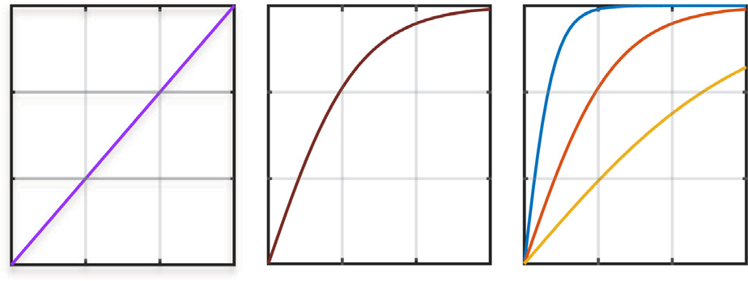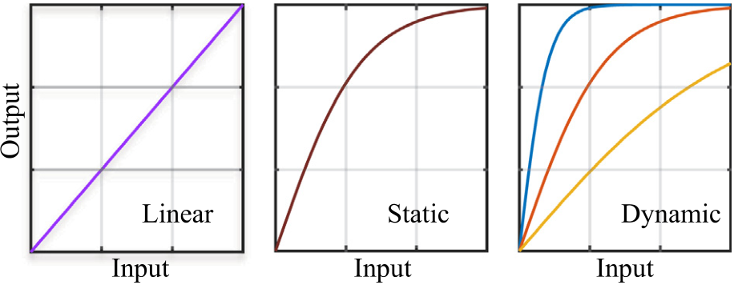

*Q. Fu et al.*  *Array 17 (2023) 100272*

**Fig. 2.** Input–output relationships of linear, static and dynamic contrast normalization models. In the dynamic model, the output is affected by the Gaussian normalized field, while in the static and linear models, the relationship between input and output is fixed.

collected by the eyelet. The input to the proposed model is *𝐿*(*𝑥, 𝑦, 𝑡*) ∈R3where *𝑥* and *𝑦* represent abscissa and ordinate of the matrix, and *𝑡* is the temporal position of the visual streams. In the propose model, every photoreceptor retrieves preliminary motion information by calculating luminance change over time:

*𝑃* (*𝑥, 𝑦, 𝑡*) = ∫

where *𝛿* is the unit impulse function. Note that for digital signals we (*𝛿*(*𝑡* − *𝜏*) − *𝛿*(*𝑡* − *𝛥𝑡* − *𝜏*))*𝐿*(*𝑥, 𝑦, 𝜏*)*𝑑𝜏*  (1)

process, the time is discrete.

*3.2. Computational lamina*

Lamina layer locates in the early stage of insect’s visual information processing. Notably, the photoreceptors of Retina synapse onto the Lamina form the starting nerve cells of ON/OFF channels through oper-ations by polarity inter-neurons. In the process of transmission, visual signals are divided into two parts to enter ON/OFF channels connecting different nerve cells in next Medulla layer. This shunt mechanism can be calculated by half-wave rectification as follows:

*𝑃𝑜𝑛*(*𝑥, 𝑦, 𝑡*) = [*𝑃* (*𝑥, 𝑦, 𝑡*)]+*, 𝑃𝑜𝑓𝑓* (*𝑥, 𝑦, 𝑡*) = −[*𝑃* (*𝑥, 𝑦, 𝑡*)]− (2)

where [*𝑥*]+, [*𝑥*]−are described mathematically as

[*𝑥*]+= max(*𝑥,* 0)*,* [*𝑥*]−= min(*𝑥,* 0) (3)

*3.3. Computational medulla*

Medulla layer, located in the middle region of optic lobe, plays a central role to coordinate motion and contrast vision in the proposed neural model. The stained micro-graph of the Medulla layer shows that there is an obvious hierarchical structure in this layer, and various synapses extend into different fibre layers for signal transmission and interaction (see Fig. 1). For imitating this, the computational Medulla layer consists of three parts of neural computation.

*Contrast normalization mechanism* Firstly, the signals delivered by start-ing nerve cells of ON/OFF channels will undergo an instantaneous nor-malized feedback operation, which is the contrast suppression mecha-nism. There are three forms of this mechanism, namely linear, static, and dynamic normalization as shown in Fig. 2. These can be expressed by the following formulas:

|  |  |  |  |
| --- | --- | --- | --- |
| Linear: *𝑀𝑜𝑛*∕*𝑜𝑓𝑓* (*𝑥, 𝑦, 𝑡*) = *𝑃𝑜𝑛*∕*𝑜𝑓𝑓* (*𝑥, 𝑦, 𝑡*) | | | |
| Static: *𝑀𝑜𝑛*∕*𝑜𝑓𝑓* (*𝑥, 𝑦, 𝑡*) = tanh( | *𝑃𝑜𝑛*∕*𝑜𝑓𝑓* (*𝑥, 𝑦, 𝑡*) )  *𝛼*1  *𝑃𝑜𝑛*∕*𝑜𝑓𝑓* (*𝑥, 𝑦, 𝑡*) | ) | (4) |
| Dynamic: *𝑀𝑜𝑛*∕*𝑜𝑓𝑓* (*𝑥, 𝑦, 𝑡*) = tanh( |
| *̂𝑃𝑜𝑛*∕*𝑜𝑓𝑓* (*𝑥, 𝑦, 𝑡*) + *𝛼*1 |  |
| Note that we apply the dynamic suppression in this neural model which has been verified to fit best the physiological results [30,60]. Here *𝑡𝑎𝑛ℎ* operation indicates the hyperbolic tangent function. The coefficient *𝛼*1 | | | |

4

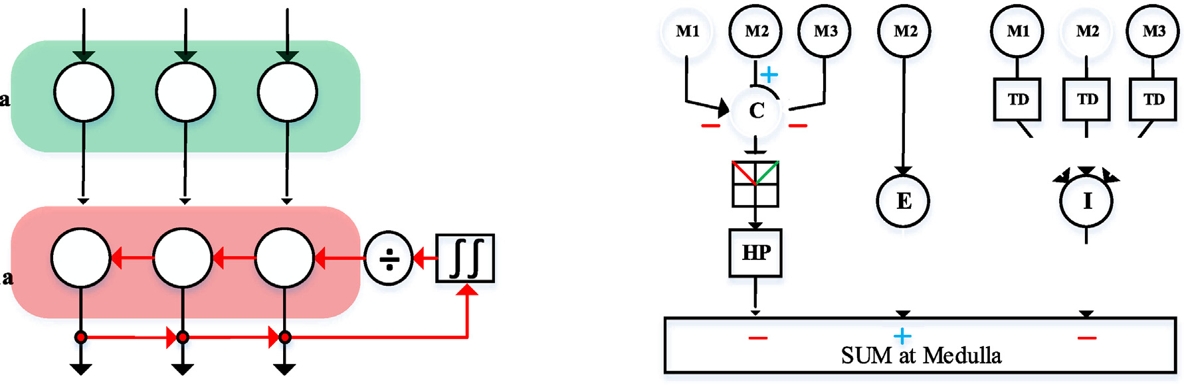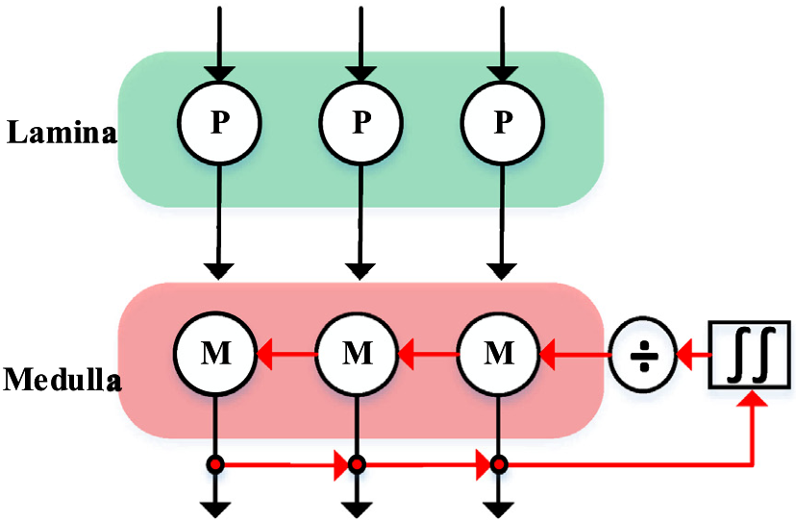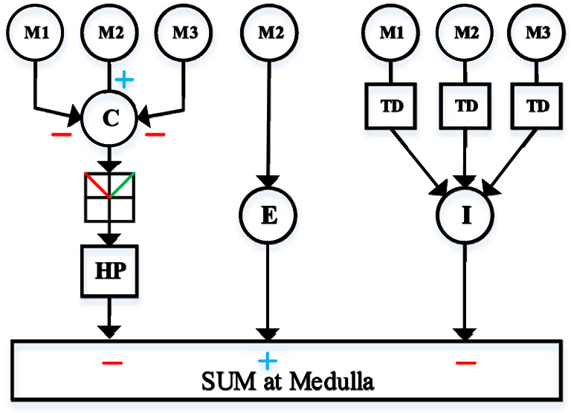

|  |  |  |
| --- | --- | --- |
| *Q. Fu et al.* |  | *Array 17 (2023) 100272* |
|  |

**Fig. 3.** (a) Diagram of instantaneous feedback normalization in ON/OFF channels. Contrast normalization is the feedback of the combination of partial medulla neurons. (b) Illustration of parallel motion and contrast calculation and convergence. Abbreviations ‘C’, ‘E’, ‘I’, ‘TD’ and ‘HP’ are shorthand for contrast, excitation, inhibition, time delay and high-pass filtering.

*𝛽* is the inhibition weight coefficient, which represents the influence of inhibitory cells on excited cells. Then, because the motion information is mixed with a large amount of contrast information of natural scenes, the motion channel needs to converge with the contrast channel (see Fig. 3(b)). At the time of convergence, the motion information is sub-tracted from the contrast information to weaken the influence of high-contrast optical flow on looming detection. At the same time, through half-wave rectification, the negative-sign signals will be filtered out.

*𝑆𝑜𝑛*(*𝑥, 𝑦, 𝑡*) = [*𝑆𝑜𝑛*(*𝑥, 𝑦, 𝑡*) − *𝐶𝑜𝑛*(*𝑥, 𝑦, 𝑡*)]+ (16)

*𝑆𝑜𝑓𝑓* (*𝑥, 𝑦, 𝑡*) = [*𝑆𝑜𝑓𝑓* (*𝑥, 𝑦, 𝑡*) − *𝐶𝑜𝑓𝑓* (*𝑥, 𝑦, 𝑡*)]+ (17)

*3.4. Computational Lobula*

Lobula layer is the last nerve layer of insect optic lobe (Fig. 1). It has a large number of motion sensitive neurons, which can quickly capture the edge information of moving objects in the field of vision and respond to the target accordingly. After harmonizing motion and contrast features in the Medulla layer, the Lobula layer integrates polarity signals from ON/OFF channels at two levels. First at the local level, excitations are integrated obeying the supra-linear rule.

*𝑆*(*𝑥, 𝑦, 𝑡*) = *𝜃*1 ∗*𝑆𝑜𝑛*(*𝑥, 𝑦, 𝑡*) + *𝜃*2 ∗*𝑆𝑜𝑓𝑓* (*𝑥, 𝑦, 𝑡*) (18) + *𝜃*3 ∗*𝑆𝑜𝑛*(*𝑥, 𝑦, 𝑡*) ∗*𝑆𝑜𝑓𝑓* (*𝑥, 𝑦, 𝑡*)

Here, the combination of *𝜃*1*, 𝜃*2*, 𝜃*3 represents the influence coefficient of each channel. After that, a grouping mechanism acts to enhance the extraction of looming cues, alleviate effect of dynamic background clutter and reduce isolated excitation by convolution and thresholding processes, described as   
*𝐶𝑒*(*𝑥, 𝑦, 𝑡*) = ∬ *𝑆*(*𝑢, 𝑣, 𝑡*)*𝐾𝑔*(*𝑥* − *𝑢, 𝑦* − *𝑣*)*𝑑𝑢𝑑𝑣*  (19)

(20) *𝜔*(*𝑡*) = *𝛥𝐶* + max(|*𝐶𝑒*(*𝑥, 𝑦, 𝑡*)|) ∗ *𝐶*−1 *𝐺*(*𝑥, 𝑦, 𝑡*) = *𝑆*(*𝑥, 𝑦, 𝑡*) ∗ *𝐶𝑒*(*𝑥, 𝑦, 𝑡*) ∗ *𝜔*(*𝑡*)−1 (21)

*̂𝐺*(*𝑥, 𝑦, 𝑡*) = { *𝐺*(*𝑥, 𝑦, 𝑡*) if *𝐺*(*𝑥, 𝑦, 𝑡*) ≥ *𝑇𝑔*  otherwise (22)

Concretely, a passing coefficient matrix *𝐶𝑒* is obtained by a convolution process with an equally weighted kernel *𝐾𝑔*. *𝜔* is a scale parameter updated at every time. *𝐶𝑤* is a constant, and *𝛥𝐶* stands for a small real number. *𝑇𝑔* indicates the threshold in grouping mechanism.

Finally, the looming sensitive neuron in the Lobula collects all movement information and converts it into membrane potential. The computations are as follows:

*𝑘*(*𝑡*) = ∫1∫1 *̂𝐺*(*𝑥, 𝑦, 𝑡*)*𝑑𝑥𝑑𝑦*  (23) *𝑟*  *𝑐*

5

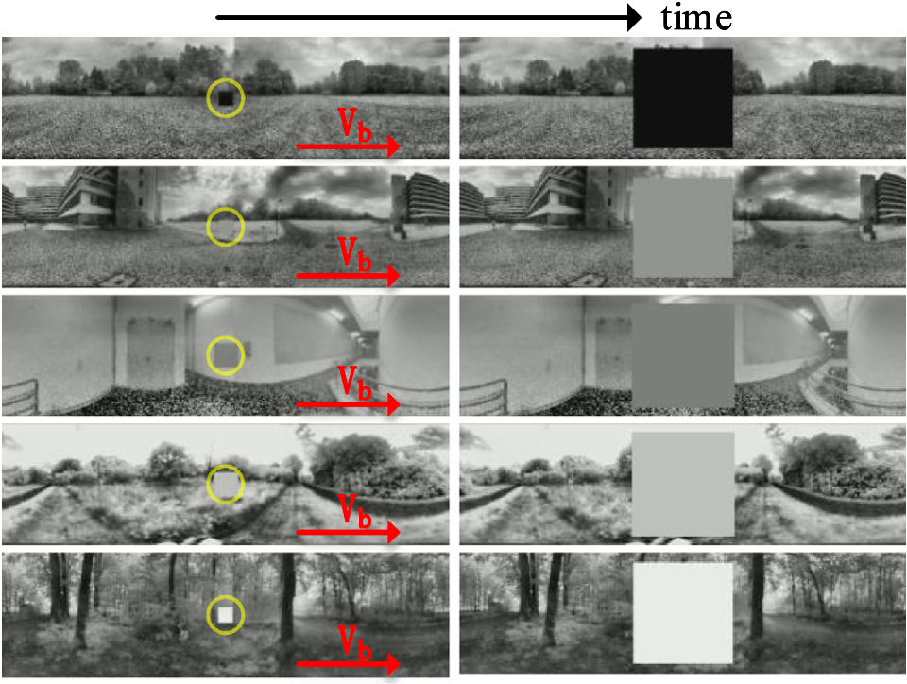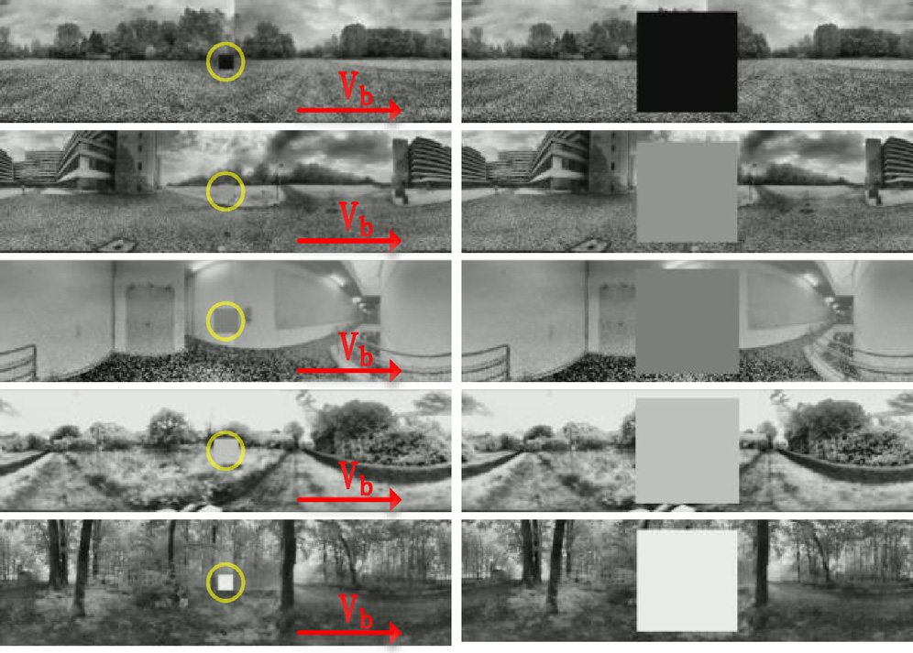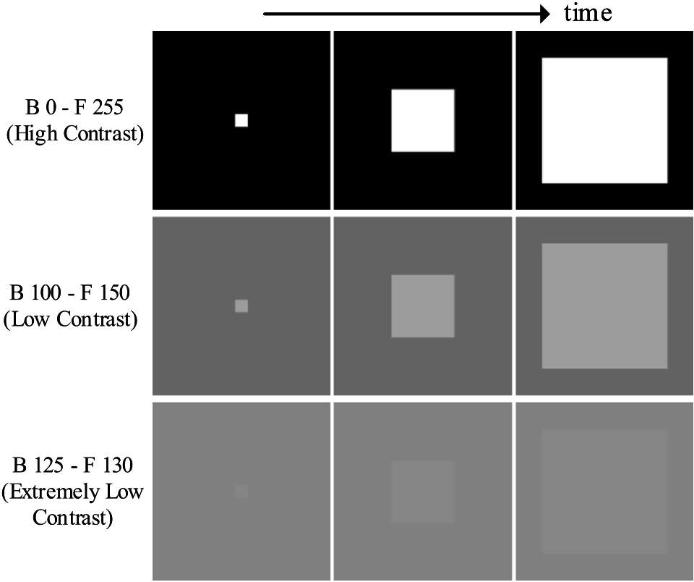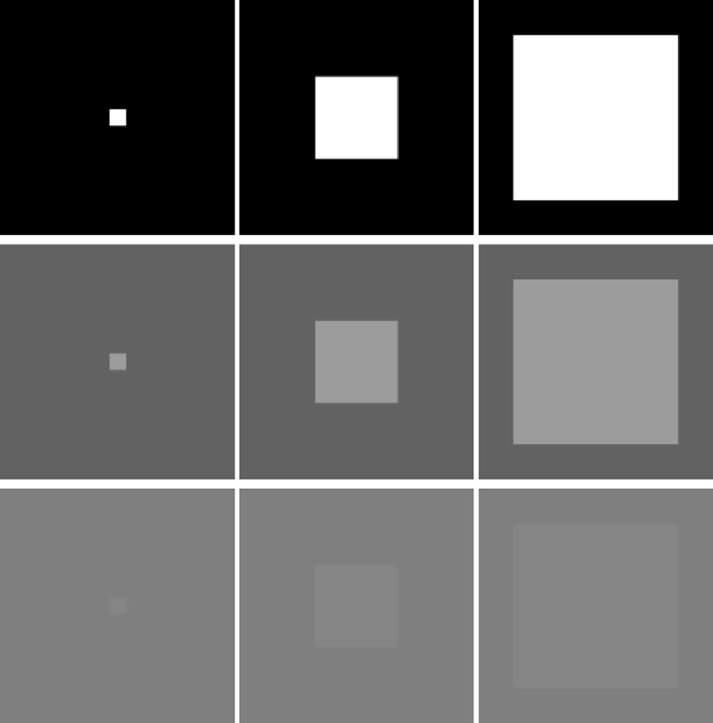

*Q. Fu et al.*  *Array 17 (2023) 100272*

**Fig. 4.** Samples of looming-square in clean-and-consistent background with different contrast between them. ‘B’ and ‘F’ respectively represent the grey value of background and foreground looming squares. **The stimuli of extremely low-contrast looming is depicted at bottom**.

**Fig. 5.** Samples from thousands looming processes within a variety of cluttered moving scenes: the background shifts rightward at a constant speed *𝑉𝑏*; the foreground looming squares vary at grey scales.

characteristics of the proposed neural model with emphasis laid on performance in extremely low-contrast scenarios, and against various natural signals. After that, we show improvement based upon the incorporation of ON/OFF channels in looming detection. Lastly, as the contrast neural computation is the main novelty of this modelling research upon previous works, we look into the effects of dynamic normalization mechanism, and ON/OFF parallel contrast pathways on looming detection against high input variability.

*4.1. Setting the experiments*

We have the implementation code and data sets used in this paper uploaded to the link below.2The visual stimuli used in our experiments can be divided into two categories. Firstly, a set of visual streams

2 <https://github.com/fuqinbing/harmonizing-motion-and-contrast-vision-for-looming-detection>

6

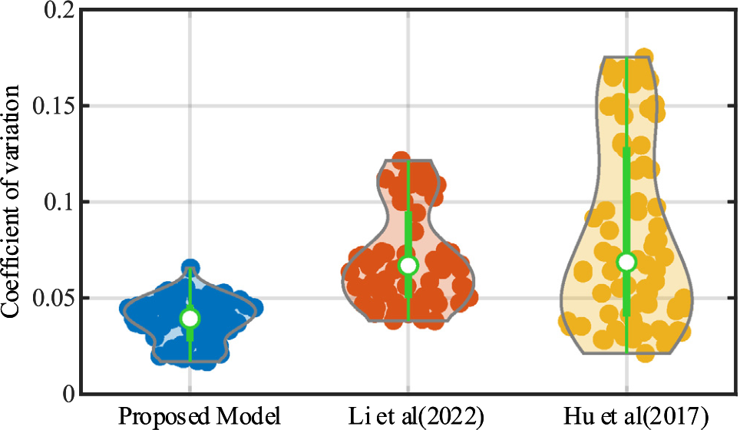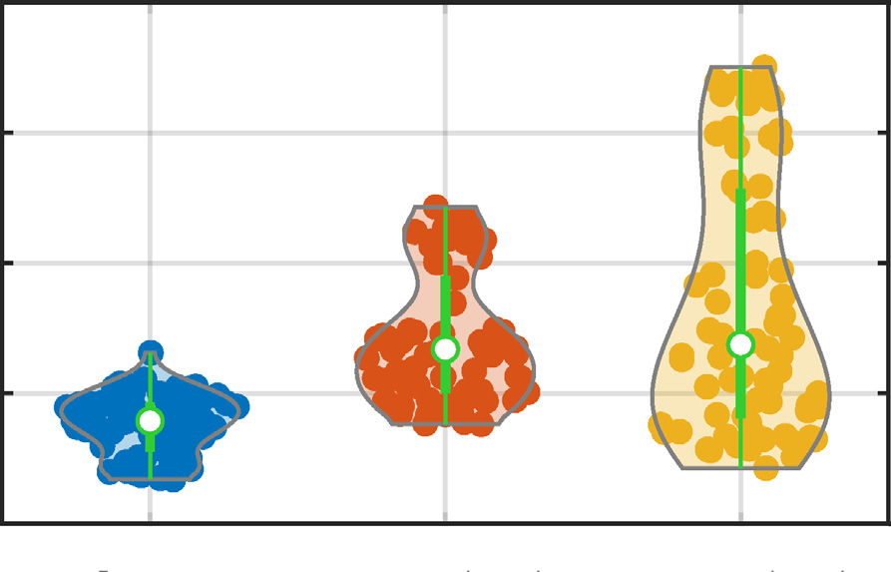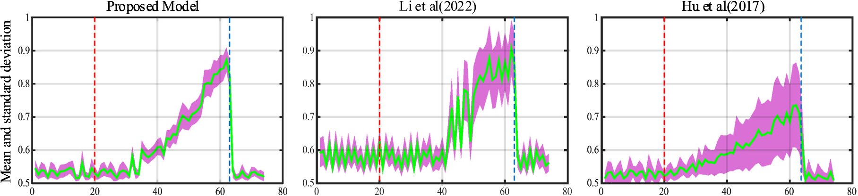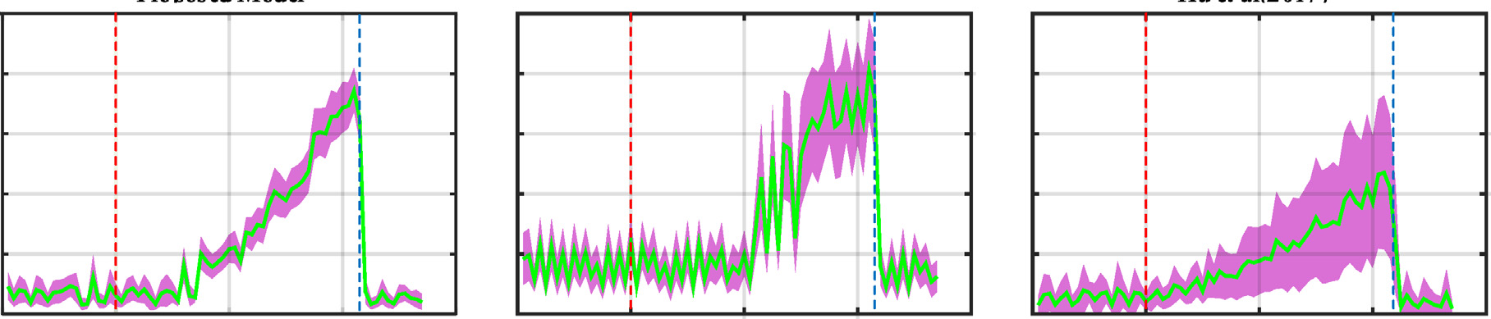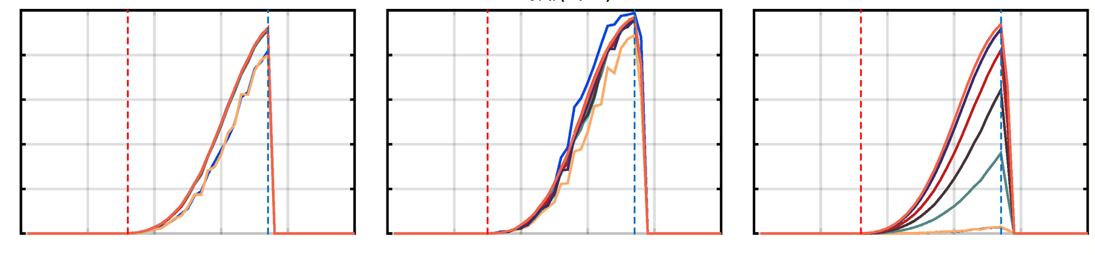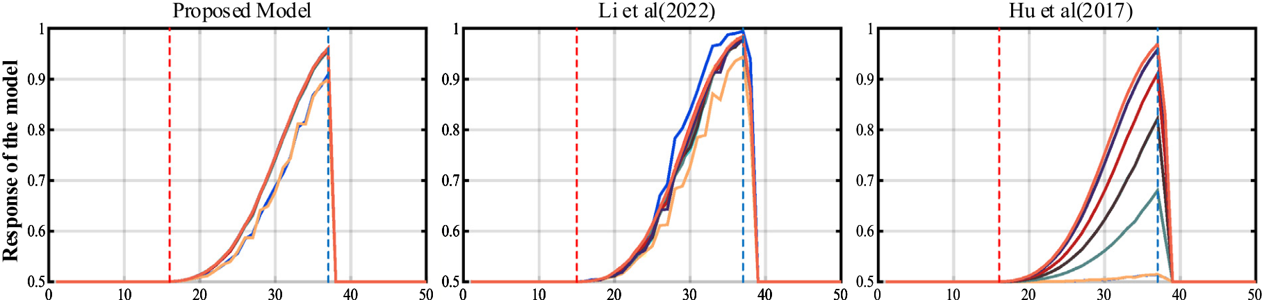

|  |  |  |  |  |
| --- | --- | --- | --- | --- |
| *Q. Fu et al.* |  |  |  | *Array 17 (2023) 100272* |



**Fig. 6.** The experimental results of the proposed model, the model of Li et al. [60], and the model of Hu et al. [36] in pure scenes. ‘F’ and ‘B’ in the legend represent the

grey values of foreground and background respectively. The red and blue dashed lines indicate the ground-truth time window of looming process. Compared to the two previous

methods, **the proposed model (left panel) performs more consistently, and can recognize looming motion with extremely low contrast**. (For interpretation of the references

to colour in this figure legend, the reader is referred to the web version of this article.)

|  |  |  |
| --- | --- | --- |
|  |  |  |

**Fig. 7.** The statistical responses of the proposed model and the comparative models against a variety of natural signals. The red and blue dashed lines indicate the ground-truth

time window of looming process. The green solid line represents the average output of the model with respect to time, and the purple shadow represents the corresponding standard

deviation. **The proposed model (left panel) performs more robustly against high input variability**. (For interpretation of the references to colour in this figure legend, the

reader is referred to the web version of this article.)

Secondly, Fig. 7 compares the statistical responses between the   
proposed method and the two comparative models against natural   
signals. From another perspective, Fig. 8 represents the dispersion of   
the coefficient of variation for each tested model. It is clear that the   
variation of our proposed model relative to the model of Hu et al. [36]   
and the model of Li et al. [60] is much lower and the coefficient distri-  
bution is denser and smaller. In addition, the corresponding box-plots   
have smaller inner spacing which indicates that our proposed model   
is more robust against natural scenes with drastic contrast changes.   
Importantly, we also solve the problem of high-frequency oscillations   
of response between frame-55 and frame-62 observed in the model of   
Li et al. [60] through the effective coordination of motion and contrast   
neural computation in four separate ON/OFF channels. Our proposed   
model peaks more smoothly to looming motion, and is more robust to   
irrelevant background movements.

**Fig. 8.** The violin diagram of the statistical results: in each violin, the coloured dots indicate the coefficient of variation. The contour of violin (grey solid line) indicates the distribution of coefficient of variation. The denser the distribution is, the more prominent the contour is. The green in the middle of the violin represents the box plot of the coefficient of variation. **The proposed model outperforms the two comparative models against looming motion in thousands of dynamic scenes**. (For interpretation of the references to colour in this figure legend, the reader is referred to the web version of this article.)

of the model will be greatly affected by the contrast representing the largest variance to the tested data. Both of our proposed model and the model of Li et al. [60] are able to detect looming motion in low-contrast environments. In contrast to the model of Li et al. [60], the output of our proposed model is more consistent across different contrasts.

7

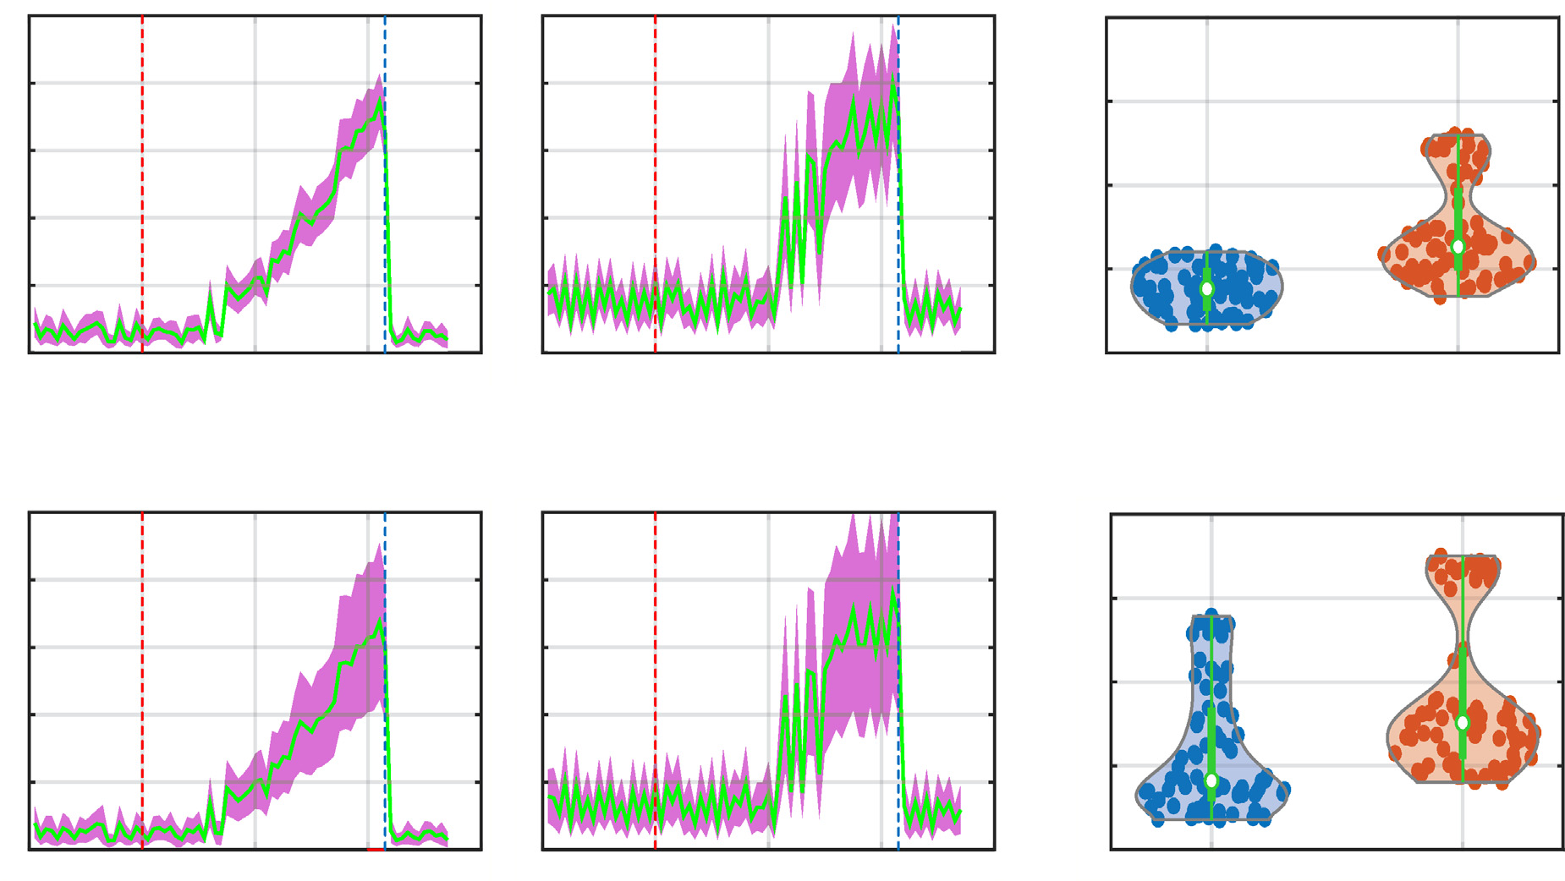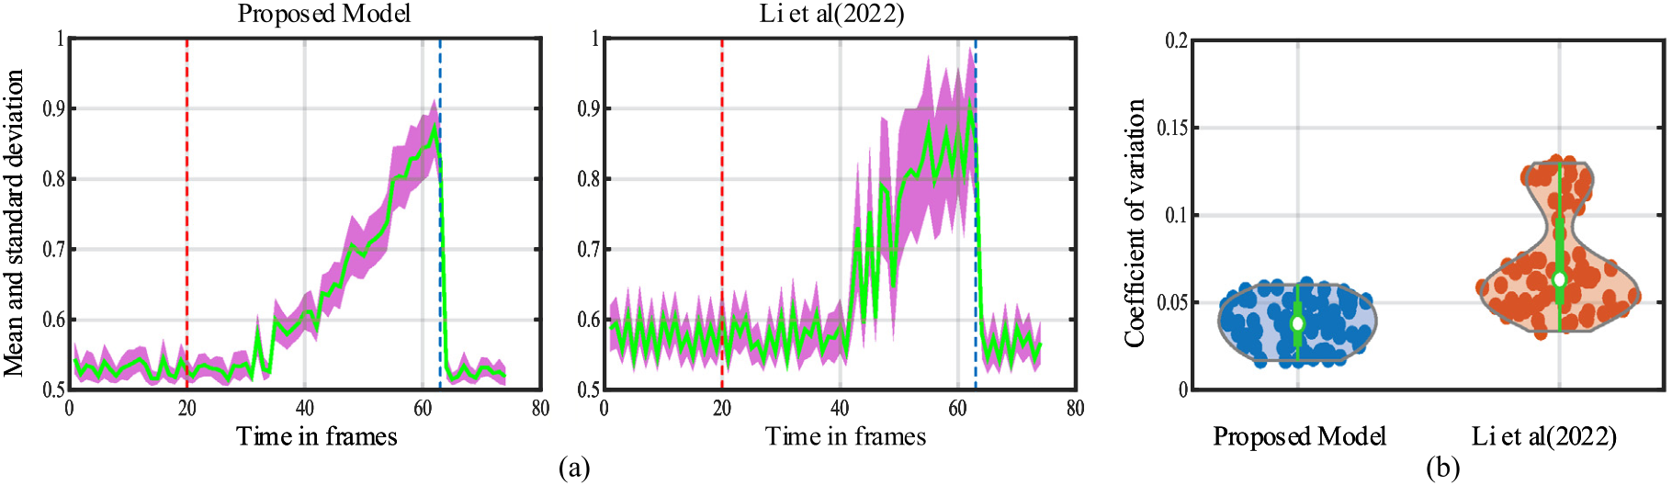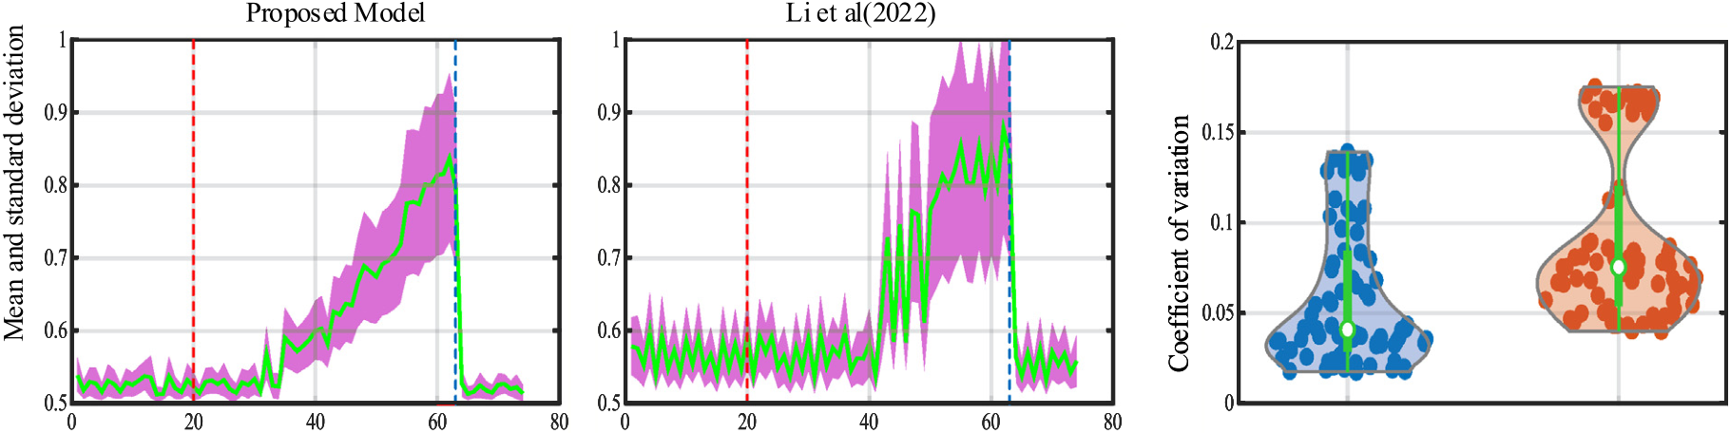

|  |  |  |  |  |
| --- | --- | --- | --- | --- |
| *Q. Fu et al.* |  |  |  | *Array 17 (2023) 100272* |
|  |

**Fig. 9.** The statistical results of the proposed model and the comparative model [60] in different background illuminations: (a) the mean and standard deviation of the model output after the background grey value increased by 20%. (b) the violin plots formed by the coefficient of variation corresponding to (a). (c) the results of background grey value reduced by 20%. (d) the corresponding violin figure to (c). **The proposed model performs more robustly against increase and decrease of background illumination which peaks more smoothly to looming motion**.

significantly by incorporating the ON/OFF channels, in comparison with the model of Li et al. [60] that processes motion and contrast vi-sion regardless of polarity changes, i.e., ON-contrast and OFF-contrast. Precisely, the proposed model peaks more smoothly to looming motions in a large number of different natural scenes. The statistical results show the proposed model has more densely distributed coefficients of variation and smaller inner distances. This suggests that our proposed model is invulnerable to environmental illumination.

*4.5. Investigation on contrast neural computation*

In the last kind of experiments, as the contrast neural computation is the main novelty of this modelling research, and plays crucial roles in enhancing the robustness of looming detection against natural signals of high input variability, we investigate two factors that lead the performance improvement.

The first is the baseline sensitivity parameter of dynamic contrast normalization that open the gates for ON/OFF motion signals, i.e., *𝛼* in Eq. (4). We adopt three different values in the proposed model tested by all the original 1100 natural data. The statistical responses are shown in Fig. 10. Specifically, when the baseline sensitivity is very small (*𝛼* = 0*.*5, the middle panel of Fig. 10), the looming-detecting neural model is also activated by movements induced by the shifting of natural background. Increasing the baseline sensitivity improves the model performance indicating the dynamic contrast normalization also works effectively to suppress the cluttered background movement. The model represents smaller fluctuations and variance of response to background movements. In addition, the model can maintain such robust performance even increasing to a relatively larger value (*𝛼* = 10, the right panel of Fig. 10). Note that in the previous experiments, the selected value of the baseline sensitivity is *𝛼* = 3 (the left panel of Fig. 10) which can achieve the best performance in our investigation. The second is the parallel ON/OFF contrast pathways that neutralize strong excitations induced by high-contrast, local ON/OFF motion. To

8

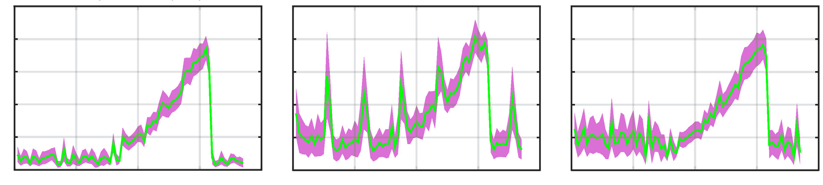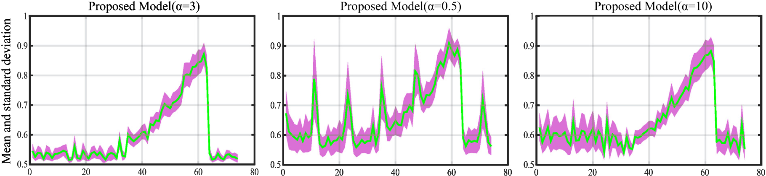

*Q. Fu et al.*  *Array 17 (2023) 100272*

**Fig. 10.** The statistical responses of the proposed model under the investigation on baseline sensitivity of dynamic contrast normalization: three baseline values are applied for

investigation, respectively.

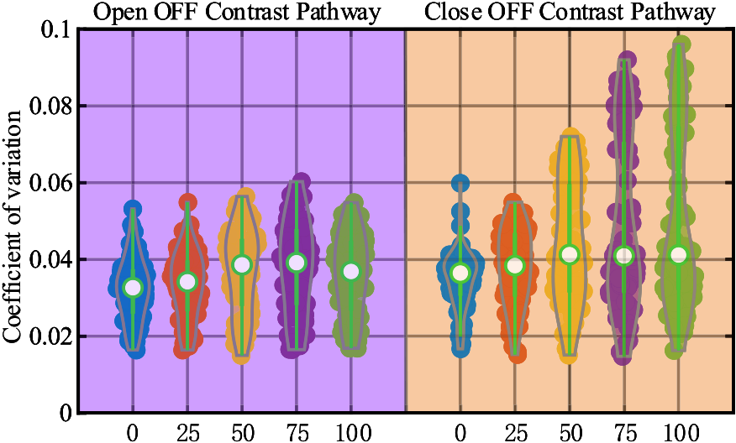

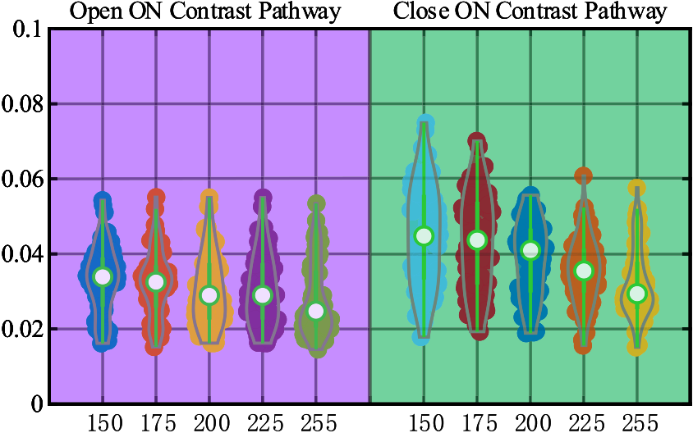

**Fig. 11.** The violin plots of examination on closing either ON or OFF contrast pathway in looming detection against natural signals: the *𝑋*-axis indicates different grey values of foreground looming-squares and the *𝑌* -axis indicates coefficient of variation. **The ON/OFF contrast pathways work effectively to maintain the robustness of the proposed model for detection of low-contrast looming motion**.

**5. Conclusion and discussion**

This paper has presented a novel way of coordinating contrast and motion vision to improve effectively the performance of looming de-tection in extremely low-contrast scenarios, and against a large variety of natural signals. The proposed neural model features feed-forward visual processing in a stratified neural network with four bio-plausible parallel ON/OFF channels encoding polarity motion and contrast in-formation separately. The contrast neural computation is the main novelty of this modelling research as it first works as an instant, dy-namic normalization mechanism to open the gates for ON/OFF motion signals. There are also ON/OFF contrast pathways to neutralize high-contrast local ON/OFF motion induced excitations, in order to stabilize model response against high input variability of natural scenes. Accord-ingly, the proposed model performs consistently in highly variable, and various-contrasted scenes.

To corroborate the proposed method, we have crafted a new data set consisting of thousands of looming-square motions in cluttered and dynamic backgrounds. To highlight our achievements, the comparative experiments have been carried out. The results verify our proposed method is more robust for looming detection in natural scenes, espe-cially at extremely low contrast. Separating motion and contrast into ON/OFF channels works effectively to alleviate the response fluctuation against natural signals, and make the visual system peak more smoothly to looming motion.

For resolving real-world, complicated detection problems, recent years have witnessed much progress based upon image processing and deep learning methods [64,65], as well as advanced sensor strate-gies [66]. We insist another promising way is drawing lessons from neuroscience on how animals deal with similar situations. Insect in-telligence is featured by efficiency and parsimony that can offer a number of excellent paradigms to build artificial vision systems and neuromorphic sensors. In this regard, the proposed approach is also of great potential to be utilized in hardware applications like bio-inspired robotic systems [67,68], and micro/aerial robotic systems [19,20].

9

*Q. Fu et al.*  *Array 17 (2023) 100272*

[5] [Yue S, Rind FC. A collision detection system for a mobile robot inspired by the locust visual system. In: Proceedings of the 2005 IEEE international conference on robotics and automation. ICRA, IEEE; 2005, p. 3832–7.](http://refhub.elsevier.com/S2590-0056(22)00105-9/sb5)

[6] [Fu Q, Hu C, Liu T, Yue S. Collision selective LGMDs neuron models research benefits from a vision-based autonomous micro robot. In: Proceedings of the 2017 IEEE/RSJ international conference on intelligent robots and systems. IROS, IEEE; 2017, p. 3996–4002.](http://refhub.elsevier.com/S2590-0056(22)00105-9/sb6)

[7] [Cizek P, Faigl J. Self-supervised learning of the biologically-inspired obstacle avoidance of hexapod walking robot. Bioinspir Biomim 2019;14(4):046002.](http://refhub.elsevier.com/S2590-0056(22)00105-9/sb7)

[8] [Milde MB, Blum H, Dietmüller A, Sumislawska D, Conradt J, Indiveri G, et al.](http://refhub.elsevier.com/S2590-0056(22)00105-9/sb8)

[Obstacle avoidance and target acquisition for robot navigation using a mixed signal analog/digital neuromorphic processing system. Front Neurorobotics 2017;11:1–17.](http://refhub.elsevier.com/S2590-0056(22)00105-9/sb8)

[Y. Parameter optimization](http://refhub.elsevier.com/S2590-0056(22)00105-9/sb9) [9] [Salt](http://refhub.elsevier.com/S2590-0056(22)00105-9/sb9)  [L, Howard D,](http://refhub.elsevier.com/S2590-0056(22)00105-9/sb9)  [Indiveri G, Sandamirskaya](http://refhub.elsevier.com/S2590-0056(22)00105-9/sb9)   
 [and](http://refhub.elsevier.com/S2590-0056(22)00105-9/sb9)  [learning](http://refhub.elsevier.com/S2590-0056(22)00105-9/sb9)  [in](http://refhub.elsevier.com/S2590-0056(22)00105-9/sb9)  [a](http://refhub.elsevier.com/S2590-0056(22)00105-9/sb9)  [spiking](http://refhub.elsevier.com/S2590-0056(22)00105-9/sb9)  [neural](http://refhub.elsevier.com/S2590-0056(22)00105-9/sb9)  [network](http://refhub.elsevier.com/S2590-0056(22)00105-9/sb9)  [for](http://refhub.elsevier.com/S2590-0056(22)00105-9/sb9)  [UAV](http://refhub.elsevier.com/S2590-0056(22)00105-9/sb9)  [obstacle](http://refhub.elsevier.com/S2590-0056(22)00105-9/sb9)  [avoidance](http://refhub.elsevier.com/S2590-0056(22)00105-9/sb9)  [Trans](http://refhub.elsevier.com/S2590-0056(22)00105-9/sb9)  [Neural](http://refhub.elsevier.com/S2590-0056(22)00105-9/sb9)  [Netw](http://refhub.elsevier.com/S2590-0056(22)00105-9/sb9)  [Learn](http://refhub.elsevier.com/S2590-0056(22)00105-9/sb9)  [Syst targeting](http://refhub.elsevier.com/S2590-0056(22)00105-9/sb9)  [neuromorphic](http://refhub.elsevier.com/S2590-0056(22)00105-9/sb9)  [processors.](http://refhub.elsevier.com/S2590-0056(22)00105-9/sb9)  [IEEE](http://refhub.elsevier.com/S2590-0056(22)00105-9/sb9)   
 [2020;31(9):3305–18.](http://refhub.elsevier.com/S2590-0056(22)00105-9/sb9)

[10] [Zhao J, Ma X, Fu Q, Hu C, Yue S. An LGMD based competitive collision avoid-ance strategy for UAV. In: Artificial intelligence applications and innovations. Springer International Publishing; 2019, p. 80–91.](http://refhub.elsevier.com/S2590-0056(22)00105-9/sb10)

[11] [Yue S, Rind FC, Keil MS, Cuadri J, Stafford R. A bio-inspired visual collision detection mechanism for cars: Optimisation of a model of a locust neuron to a novel environment. Neurocomputing 2006;69(13–15):1591–8.](http://refhub.elsevier.com/S2590-0056(22)00105-9/sb11)

[12] [Stafford R, Santer RD, Rind FC. A bio-inspired visual collision detection mech-anism for cars: Combining insect inspired neurons to create a robust system. Biosystems 2007;87(2–3):164–71.](http://refhub.elsevier.com/S2590-0056(22)00105-9/sb12)

[13] [Krejan A, Trost A. LGMD-based bio-inspired algorithm for detecting risk of collision of a road vehicle. In: Proceedings of the 2011 IEEE 7th international symposium on image and signal processing and analysis. IEEE; 2011, p. 319–24.](http://refhub.elsevier.com/S2590-0056(22)00105-9/sb13) [14] [Hartbauer M. Simplified bionic solutions: A simple bio-inspired vehicle collision detection system. Bioinspir Biomim 2017;12(2):026007.](http://refhub.elsevier.com/S2590-0056(22)00105-9/sb14)

[15] [Reich](http://refhub.elsevier.com/S2590-0056(22)00105-9/sb15)  [GM,](http://refhub.elsevier.com/S2590-0056(22)00105-9/sb15)  [Antoniou](http://refhub.elsevier.com/S2590-0056(22)00105-9/sb15)  [M,](http://refhub.elsevier.com/S2590-0056(22)00105-9/sb15)  [Baker](http://refhub.elsevier.com/S2590-0056(22)00105-9/sb15)  [C.](http://refhub.elsevier.com/S2590-0056(22)00105-9/sb15)  [Memory-enhanced](http://refhub.elsevier.com/S2590-0056(22)00105-9/sb15)  [cognitive](http://refhub.elsevier.com/S2590-0056(22)00105-9/sb15)  [radar](http://refhub.elsevier.com/S2590-0056(22)00105-9/sb15)  [for](http://refhub.elsevier.com/S2590-0056(22)00105-9/sb15)  [autonomous navigation. IET Radar Sonar Navig 2020;14(9):1287–96.](http://refhub.elsevier.com/S2590-0056(22)00105-9/sb15)

[16] [Arvin F, Samsudin K, Ramli AR. Development of IR-based short-range com-munication techniques for swarm robot applications. Adv Electr Comput Eng 2010;10(4):61–8.](http://refhub.elsevier.com/S2590-0056(22)00105-9/sb16)

[17] [Everett H. Sensors for mobile robots: Theory and application. Taylor & Francis;](http://refhub.elsevier.com/S2590-0056(22)00105-9/sb17)  [1995.](http://refhub.elsevier.com/S2590-0056(22)00105-9/sb17)

[18] Mukhtar A, Xia L, Tang TB. Vehicle detection techniques for collision avoidance systems: A review. IEEE Trans Intell Transp Syst 2015;16(5):2318–38. [http: //dx.doi.org/10.1109/TITS.2015.2409109](http://dx.doi.org/10.1109/TITS.2015.2409109).

[19] [Serres JR, Ruffier F. Optic flow-based collision-free strategies: From insects to](http://refhub.elsevier.com/S2590-0056(22)00105-9/sb19)  [robots. Arthropod Struct Dev 2017;46(5):703–17.](http://refhub.elsevier.com/S2590-0056(22)00105-9/sb19)

[20] [Fu Q, Wang H, Hu C, Yue S. Towards computational models and appli-cations of insect visual systems for motion perception: A review. Artif Life 2019;25(3):263–311.](http://refhub.elsevier.com/S2590-0056(22)00105-9/sb20)

[21] Fu Q, Hu C, Peng J, Yue S. Shaping the collision selectivity in a looming sensitive neuron model with parallel ON and OFF pathways and spike frequency adaptation. Neural Netw 2018;106:127–43. [http://dx.doi.org/10.1016/j.neunet. 2018.04.001](http://dx.doi.org/10.1016/j.neunet.2018.04.001).

[22] [Fu Q, Hu C, Liu P, Yue S. Towards computational models of insect motion detectors for robot vision. In: Towards autonomous robotic systems conference. 2018, p. 465–7.](http://refhub.elsevier.com/S2590-0056(22)00105-9/sb22)

[23] Fu Q, Hu C, Peng J, Rind FC, Yue S. A robust collision perception visual neural network with specific selectivity to darker objects. IEEE Trans Cybern 2019;5(12):5074–88. <http://dx.doi.org/10.1109/TCYB.2019.2946090>.

[24] [Ruffier F, Viollet S, Franceschini N. OSCAR and OCTAVE: Two bio-inspired visually guided aerial micro-robots. In: Proceedings of the 11th international conference on advanced robotics. IEEE; 2003, p. 726–32.](http://refhub.elsevier.com/S2590-0056(22)00105-9/sb24)

[25] [Franceschini N, Ruffier F, Serres J. Insect inspired autopilots. J Aero Aqua](http://refhub.elsevier.com/S2590-0056(22)00105-9/sb25)  [Bio-Mech 2010;1(1):2–10.](http://refhub.elsevier.com/S2590-0056(22)00105-9/sb25)

[26] [Ruffier F, Franceschini N. Optic flow regulation in unsteady environments: A tethered MAV achieves terrain following and targeted landing over a moving platform. J Intell Robot Syst 2015;79(2):275–93.](http://refhub.elsevier.com/S2590-0056(22)00105-9/sb26)

[27] [Floreano D, Pericet-Camara R, Viollet S, Ruffier F, Bruckner A, Leitel R, et al.](http://refhub.elsevier.com/S2590-0056(22)00105-9/sb27)

[Miniature curved artificial compound eyes. Proc Natl Acad Sci 2013;110(23).](http://refhub.elsevier.com/S2590-0056(22)00105-9/sb27) [28] [Salazar-Gatzimas E, Chen J, Creamer M, Mano O, Mandel H, Matulis C, et al.](http://refhub.elsevier.com/S2590-0056(22)00105-9/sb28)

[Direct measurement of correlation responses in drosophila elementary motion detectors reveals fast timescale tuning. Neuron 2016;92(1):227–39.](http://refhub.elsevier.com/S2590-0056(22)00105-9/sb28)

[29] [Bahl A, Serbe E, Meier M, Ammer G, Borst A. Neural mechanisms for drosophila](http://refhub.elsevier.com/S2590-0056(22)00105-9/sb29)  [contrast vision. Neuron 2015;88:1240–52.](http://refhub.elsevier.com/S2590-0056(22)00105-9/sb29)

[30] [Drews MS, Leonhardt A, Pirogova N, Richter FG, Schuetzenberger A, Braun L, et al. Dynamic signal compression for robust motion vision in flies. Curr Biol 2020;30:209–21.](http://refhub.elsevier.com/S2590-0056(22)00105-9/sb30)

10

*Q. Fu et al.*  *Array 17 (2023) 100272*

[62] [Yue S, Rind FC. Collision detection in complex dynamic scenes using an LGMD-based visual neural network with feature enhancement. IEEE Trans Neural Netw 2006;17(3):705–16.](http://refhub.elsevier.com/S2590-0056(22)00105-9/sb62)

[63] [Brinkworth RSA, O’Carroll DC. Robust models for optic flow coding in natural](http://refhub.elsevier.com/S2590-0056(22)00105-9/sb63)  [scenes inspired by insect biology. PLoS Comput Biol 2009;5(11).](http://refhub.elsevier.com/S2590-0056(22)00105-9/sb63)

[64] [Cha Y-J, Choi W, Suh G, Mahmoudkhani S. Autonomous st](http://refhub.elsevier.com/S2590-0056(22)00105-9/sb63)[ructural visual Inspection Using Region-based deep learning for detecting multiple damage types. Comput-Aided Civ Infrastruct Eng 2018;33:731–47.](http://refhub.elsevier.com/S2590-0056(22)00105-9/sb64)

11